Big Data would be the currently trending Social Media sites like Facebook, Instagram, WhatsApp and YouTube(TERA BYTES AND PETA BYTES OF DATA)

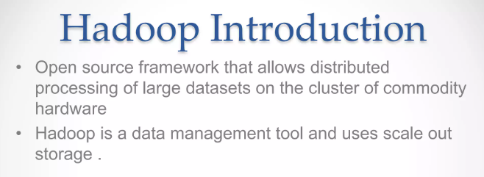

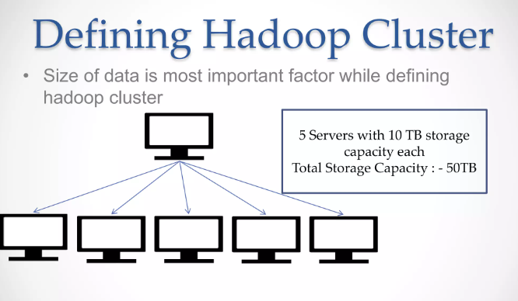

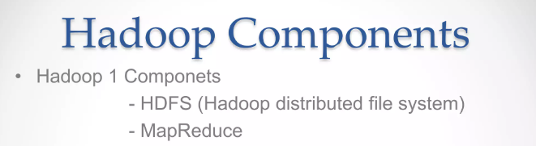

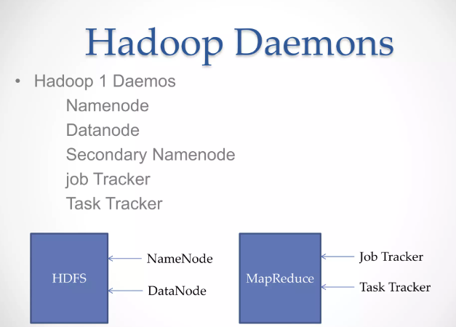

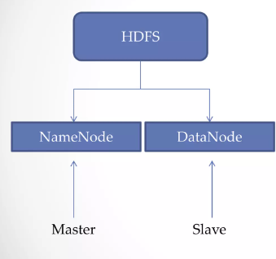

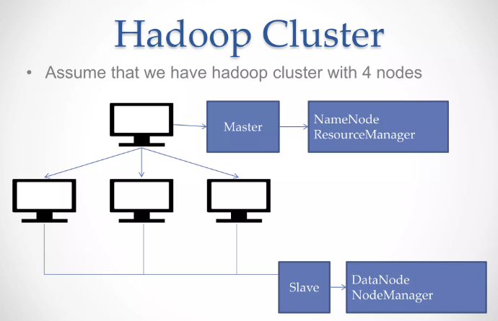

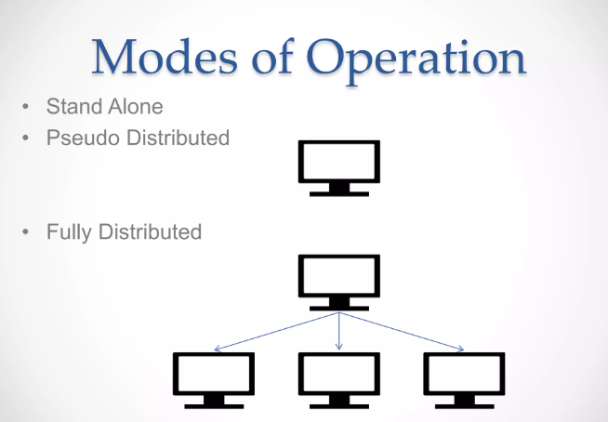

**What is Hadoop?**

* Hadoop is a Big Data framework designed and deployed by Apache Foundation.
* It is an open-source software utility that works in the network of computers in parallel to find solutions to Big Data and process it using the MapReduce algorithm.
* MapReduce is a programming model that allows us to perform parallel and distributed processing on huge data sets.

**MapReduce Tutorial: What is MapReduce?**

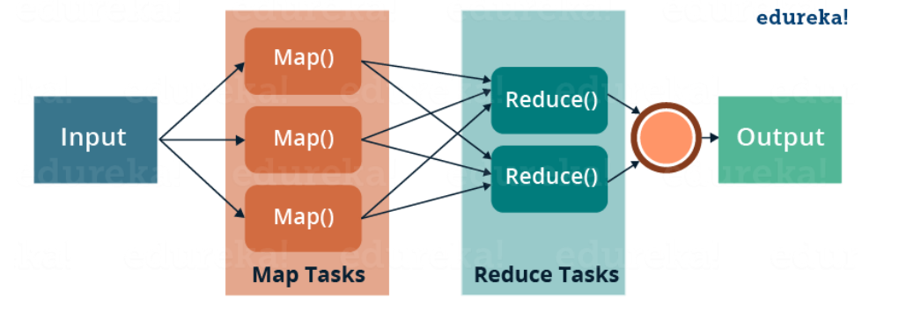

* MapReduce consists of two distinct tasks – Map and Reduce.
* As the name MapReduce suggests, the reducer phase takes place after the mapper phase has been completed.
* So, the first is the map job, where a block of data is read and processed to produce key-value pairs as intermediate outputs.
* The output of a Mapper or map job (key-value pairs) is input to the Reducer.
* The reducer receives the key-value pair from multiple map jobs.
* Then, the reducer aggregates those intermediate data tuples (intermediate key-value pair) into a smaller set of tuples or key-value pairs which is the final output

Let us understand more about MapReduce and its components. MapReduce majorly has the following three Classes. They are,

**Mapper Class**

RecordReader processes each Input record and generates the respective key-value pair. Hadoop’s Mapper store saves this intermediate data into the local disk.

**Reducer Class**

The Intermediate output generated from the mapper is fed to the reducer which processes it and generates the final output which is then saved in the **HDFS.**

**Driver Class**

The major component in a MapReduce job is a **Driver Class.** It is responsible for setting up a MapReduce Job to run-in Hadoop. We specify the names of **Mapper** and **Reducer** Classes long with data types and their respective job names.

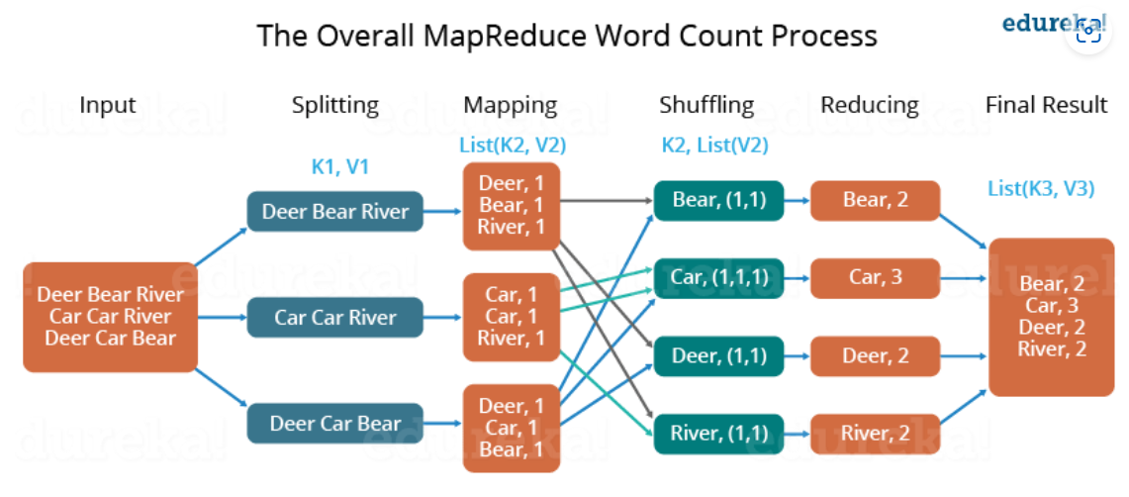

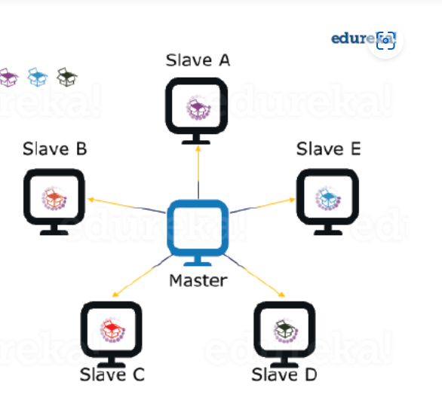

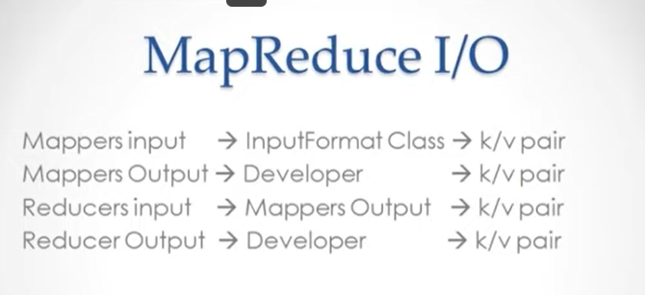

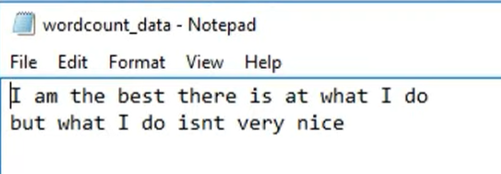

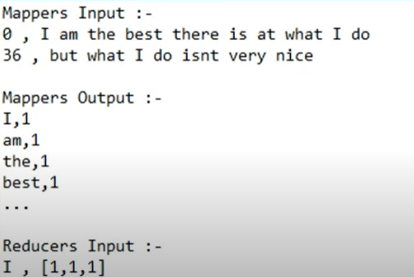

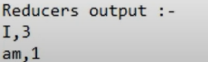

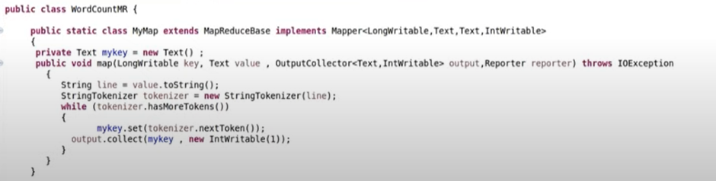

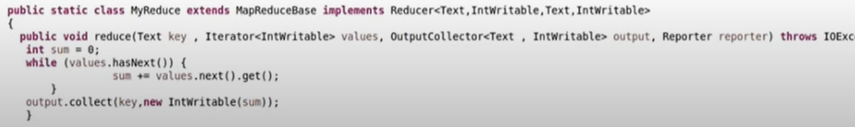

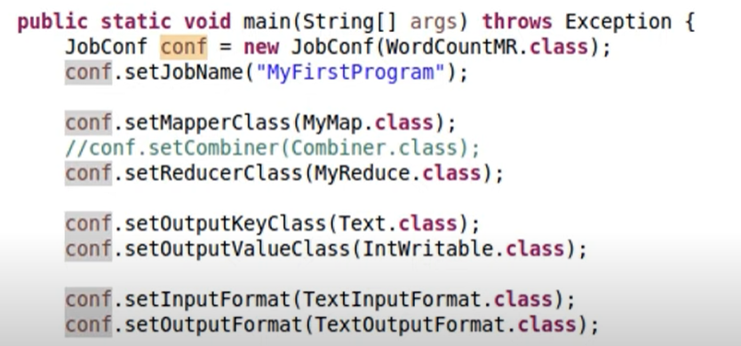

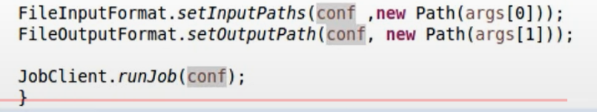

[TG117 Hindi - YouTube](https://www.youtube.com/@TechnologicalGeeksHindi/about)